# Apply filters to SQL queries

## Project description

In this project we’ll be using different SQL filter to filter out data from table based on what we need. Filtering makes the process of finding data more efficient and helps save time.

## Retrieve after hours failed login attempts

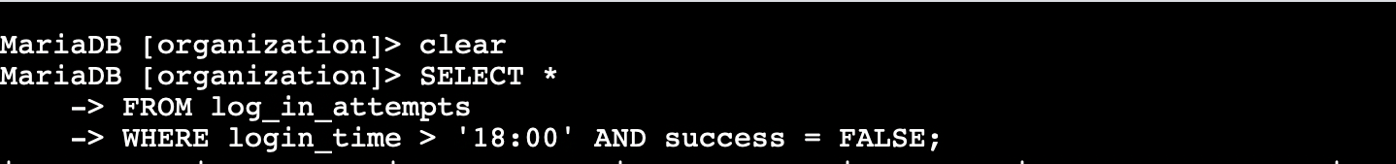

To filter out after hours failed login attempts we need to check if the login_time was after the closing time of the organization(18:00), and it was a failed login attempt. Here WHERE login_time >’18:00’ indicated that it’s after hours and success = FALSE indicates that it was a failed login attempt. AND is a logical operator that tells SQL to only print values that satisfy both conditions

## Retrieve login attempts on specific dates



To filter out login attempts on two different dates we use the OR operator. Here we need to check for date where the login_date was either ‘2022-05-09’ or ‘2022-05-08’. This is done using the OR operator as it returns all data that is on either dates.

## Retrieve login attempts outside of Mexico

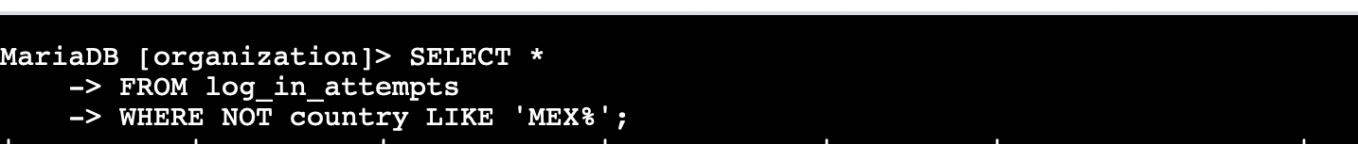

Here we need to print data that are outside of Mexico. This is a good example to use the NOT filter. NOT filter in SQL helps print everything except for certain data. In this example it prints everything except rows whose country is Mexico. Like operator and ‘MEX%’ are used to check for both Mexico and Mex in the country column

## Retrieve employees in Marketing



Here we are trying to print every row where department is Marketing and the office is anywhere in the East building

## Retrieve employees in Finance or Sales



Here we are trying to print every row where department is either Finance or Sales, and the office is anywhere in the East building

## Retrieve all employees not in IT

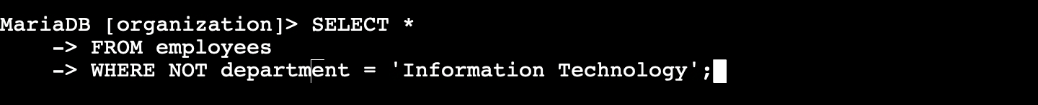

Here we are trying to print every row where the department is not Information Technology

## Summary

In this project I was able to learn how to successfully use SQL operators to filter out data from a table. The AND,OR and NOT operator make filtering data simple.